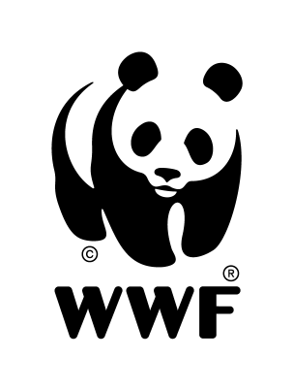

Greenpeace International and WWF joint statement on the AIDCP

26 May, 2003

For many years the bycatch of dolphins, sharks, turtles, juvenile tuna, and other marine life in the commercial tuna fisheries in the Eastern Tropical Pacific has been a case of concern. The Agreement on the International Dolphin Conservation Program (AIDCP) sets many important precedents for fisheries conservation and management that Greenpeace and WWF have been advocating for many years, precedents that are legally binding on all countries fishing for tuna in the Eastern Tropical Pacific (ETP).

In addition to dramatically reducing the allowable level of dolphin kills for the entire fishery, and mandating continual reductions toward an eventual goal of zero. It mandates implementation of a bycatch reduction program for sharks, billfish, sea turtles and juvenile tuna. The Program requires the setting of sustainable catch quotas for tuna and requires the closure of the fishery if those limits are reached. It also requires 100% observer coverage to verify compliance with all aspects of the Program.

This groundbreaking Program is strongly supported by Greenpeace and WWF.

Greenpeace and WWF credit the Program with the dramatic decrease in dolphin deaths from approximately 100,000 in 1989 to only 1500 in 2002. In our view, the International Dolphin Protection Program provides the best approach available not only for continuing to reduce dolphin mortality and improve the chances of recovery of the depleted dolphin populations, but to reduce the impacts of the fishery on the marine ecosystem as a whole.

The Agreement addresses the real and growing impact of tuna fishing on the ETP ecosystems, on other species of marine life, and establishes a program for assessing, monitoring and minimizing bycatch of juvenile tuna and non-target species. Of particular concern to Greenpeace and WWF is the bycatch associated with setting purse seine nets around floating objects such as Fish Aggregating Devices (FADs) and logs. The unsustainable rates of bycatch of numerous species of marine fauna including several species of sea turtles and sharks internationally considered to be vulnerable or endangered must be urgently addressed within the framework of the Agreement and the Inter-American Tropical Tuna Commission (IATTC).

Greenpeace and WWF believe that other countries from Latin America should join the AIDCP, and that all countries participating in the ETP fishery must remain committed to the Agreement and implement the observers program. Moreover an ecosystem based fisheries management regime should be used in all the ETP. Therefore, Greenpeace and WWF also urge all countries involved to fully commit to the development of alternative technologies and practices that ensure minimal impact on the marine environment, both target and non-target species.

Therefore, Greenpeace and WWF urge all parties to remain committed to the agreement and to improve its implementation and compliance.

Should the AIDCP collapse fishers would most certainly revert to uncontrolled operations spelling a complete disaster not only for dolphin populations but also for sharks, turtles, billfish and juvenile tuna, and even the target yellowfin tuna itself in the Eastern Pacific.

In addition, Greenpeace and WWF believe that there is an urgent need for consumers in the EU and elsewhere to be adequately informed, in order to be able to make the right choice to protect oceans life as a whole.

